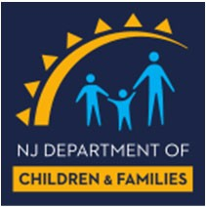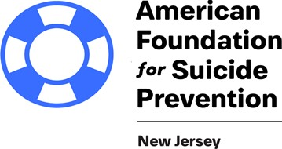

TRAUMATIC LOSS COALITIONS FOR YOUTH
17th Annual Suicide Prevention Conference

SAVE THE DATE!!!!
Topic: “Reaching for Hope”

Guest Speakers

Susan Klebold
Author & Activist Keynote Speaker

Vanessa L. McGann, PhD
Clinical Psychologist

Thursday, December 3rd, 2020 8:30 AM – 12:00 PM
VIA WEBEX
Registration information to follow…….

Supported by

THE AMERICAN FOUNDATION FOR SUICIDE PREVENTION – NEW JERSEY CHAPTER
Cost of Conference: $49

CONFERENCE TARGET AUDIENCE
TLC Coalition Members & Coordinators - Mental Health Clinicians - School Counselors School Resource Officers – Educators - School Administrators - School Psychologists - School Nurses
Division of Family Services Personnel – Certified Counselors – Social Workers - Juvenile Justice Personnel
Law Enforcement Personnel – Clergy - Substance Abuse Counselors - Child and Adult Psychiatrists Pediatricians –Parents

TRAUMATIC LOSS COALITIONS FOR YOUTH
Program funding is provided the New Jersey Department of Children & Families, Children’s System of Care in partnership with Rutgers University Behavioral Health Care.
151 Centennial Avenue, Piscataway, NJ 08854 http://ubhc.rutgers.edu/tlc/ 732-235-2810

